**“LAPORAN TUGAS INTENT”**

**PEMROGRAMAN ANDROID**



Nama : Fajar Maula Dandi

NIM : 1731710153

Kelas : MI-2F

**PROGRAM STUDI D3 MANAJEMEN INFORMATIKA**

**JURUSAN TEKNOLOGI INFORMASI**

**2019**

Membuat Sistem Next dan Intens pada Android

1. Setelah new project buat baru activity baru dengan nama MainActivity2 dan MainActivity3

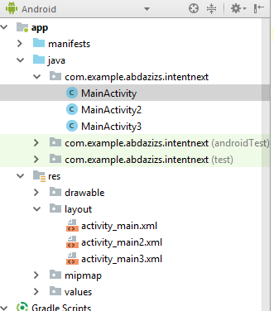

1. Olah MainActivity dengan sintak berikut:

|  |
| --- |
| **package** com.example.abdazizs.intentnext;  **import** android.content.Intent; **import** android.support.v7.app.AppCompatActivity; **import** android.os.Bundle; **import** android.view.View; **import** android.widget.Button; **import** android.widget.EditText;  **import** org.w3c.dom.Text;  **public class** MainActivity **extends** AppCompatActivity {  **private** Button **btn**;  **private** EditText **txtD**;   @Override  **protected void** onCreate(Bundle savedInstanceState) {   **super**.onCreate(savedInstanceState);  setContentView(R.layout.***activity_main***);  **btn** = (Button) findViewById(R.id.***btnKlik***);  **txtD** = (EditText) findViewById(R.id.***edittxtkampus***);  **btn**.setOnClickListener(**new** View.OnClickListener(){   @Override  **public void** onClick(View view) {  Intent i = **new** Intent(getApplicationContext(),MainActivity2.**class**);  i.putExtra(**"matkul"**, **"Perangkat Moblie"**);  i.putExtra(**"kampus"**,**txtD**.getText().toString());  startActivity(i);  }  });  } } |

1. Sintak MainActivity2

|  |
| --- |
| **package** com.example.abdazizs.intentnext;  **import** android.content.Intent; **import** android.support.v7.app.AppCompatActivity; **import** android.os.Bundle; **import** android.view.View; **import** android.widget.Button; **import** android.widget.EditText; **import** android.widget.TextView;  **public class** MainActivity2 **extends** AppCompatActivity {   **private** Button **btn**;  **private** TextView **txtV**,**txtV2**;  **private** EditText **txtNew1**,**txtNew2**,**txtNew3**,**txtNew4**;   @Override  **protected void** onCreate(Bundle savedInstanceState) {  **super**.onCreate(savedInstanceState);  setContentView(R.layout.***activity_main2***);  **txtV** = (TextView) findViewById(R.id.***matkulTarget***);  **txtV2** = (TextView) findViewById(R.id.***kampusTarget***);  **btn** = (Button) findViewById(R.id.***btnSimpan***);  **txtNew1** = (EditText) findViewById(R.id.***editNama***);  **txtNew2** = (EditText) findViewById(R.id.***editNim***);  **txtNew3** = (EditText) findViewById(R.id.***editAlamat***);  **txtNew4** = (EditText) findViewById(R.id.***editTanggal***);  Intent i = getIntent();  **final** String matkul = i.getStringExtra(**"matkul"**);  **final** String kampus = i.getStringExtra(**"kampus"**);  **txtV**.setText(matkul);  **txtV2**.setText(kampus);   **btn**.setOnClickListener(**new** View.OnClickListener(){   @Override  **public void** onClick(View view) {  Intent i = **new** Intent(getApplicationContext(),MainActivity3.**class**);  i.putExtra(**"nama"**,**txtNew1**.getText().toString());  i.putExtra(**"nim"**,**txtNew2**.getText().toString());  i.putExtra(**"alamat"**,**txtNew3**.getText().toString());  i.putExtra(**"tanggal"**,**txtNew4**.getText().toString());  i.putExtra(**"matkul2"**,matkul);  i.putExtra(**"kampus2"**,kampus);  startActivity(i);  }  });    }  } |

1. Sintak MainActivity3

|  |
| --- |
| **package** com.example.abdazizs.intentnext;  **import** android.content.Intent; **import** android.support.v7.app.AppCompatActivity; **import** android.os.Bundle; **import** android.widget.TextView;  **public class** MainActivity3 **extends** AppCompatActivity {   @Override  **protected void** onCreate(Bundle savedInstanceState) {  TextView txtNew1,txtNew2,txtNew3,txtNew4, txtMatkul,txtKampus;   **super**.onCreate(savedInstanceState);  setContentView(R.layout.***activity_main3***);  txtNew1 = (TextView) findViewById(R.id.***txtTargetNama***);  txtNew2 = (TextView) findViewById(R.id.***txtTargetNim***);  txtNew3 = (TextView) findViewById(R.id.***txtTargetAlamat***);  txtNew4 = (TextView) findViewById(R.id.***txtTargetTanggal***);  txtMatkul = (TextView) findViewById(R.id.***txtMatkul2***);  txtKampus = (TextView) findViewById(R.id.***txtKampus2***);   Intent i = getIntent();  String nama = i.getStringExtra(**"nama"**);  String nim = i.getStringExtra(**"nim"**);  String alamat = i.getStringExtra(**"alamat"**);  String tanggal = i.getStringExtra(**"tanggal"**);  String matkul = i.getStringExtra(**"matkul2"**);  String kampus = i.getStringExtra(**"kampus2"**);  txtNew1.setText(nama);  txtNew2.setText(nim);  txtNew3.setText(alamat);  txtNew4.setText(tanggal);  txtMatkul.setText(matkul);  txtKampus.setText(kampus);   } } |

1. Sintak activity_main

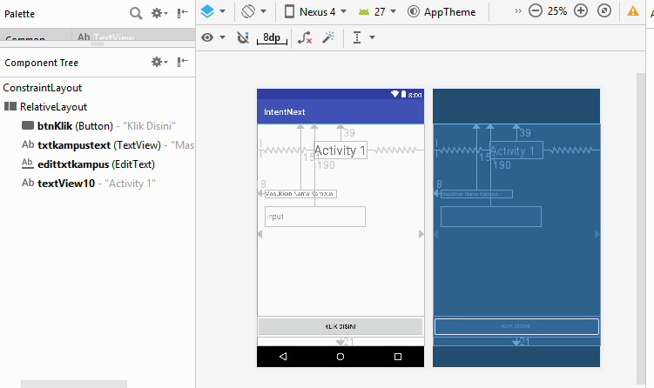

|  |
| --- |
| *<?***xml version="1.0" encoding="utf-8"***?>* <**android.support.constraint.ConstraintLayout xmlns:android="http://schemas.android.com/apk/res/android"  xmlns:app="http://schemas.android.com/apk/res-auto"  xmlns:tools="http://schemas.android.com/tools"  android:layout_width="match_parent"  android:layout_height="match_parent"  tools:context=".MainActivity"**>    <**RelativeLayout  android:layout_width="match_parent"  android:layout_height="match_parent"  app:layout_constraintBottom_toBottomOf="parent"  app:layout_constraintEnd_toEndOf="parent"  app:layout_constraintHorizontal_bias="0.0"  app:layout_constraintStart_toStartOf="parent"  app:layout_constraintTop_toTopOf="parent"  app:layout_constraintVertical_bias="1.0"**>    <**Button  android:id="@+id/btnKlik"  android:layout_width="match_parent"  android:layout_height="wrap_content"  android:layout_alignParentBottom="true"  android:layout_marginBottom="21dp"  android:text="Klik Disini"  tools:layout_editor_absoluteX="8dp"  tools:layout_editor_absoluteY="8dp"** />   <**TextView  android:id="@+id/txtkampustext"  android:layout_width="wrap_content"  android:layout_height="wrap_content"  android:layout_alignParentStart="true"  android:layout_alignParentTop="true"  android:layout_marginStart="18dp"  android:layout_marginTop="151dp"  android:text="Masukkan Nama Kampus :"  app:layout_constraintBottom_toBottomOf="parent"  app:layout_constraintLeft_toLeftOf="parent"  app:layout_constraintRight_toRightOf="parent"  app:layout_constraintTop_toTopOf="parent"** />   <**EditText  android:id="@+id/edittxtkampus"  android:layout_width="230dp"  android:layout_height="wrap_content"  android:layout_alignParentTop="true"  android:layout_alignStart="@+id/txtkampustext"  android:layout_marginTop="190dp"  android:ems="10"  android:hint="Input"  android:inputType="text"** />   <**TextView  android:id="@+id/textView10"  android:layout_width="wrap_content"  android:layout_height="wrap_content"  android:layout_alignParentTop="true"  android:layout_centerHorizontal="true"  android:layout_marginTop="39dp"  android:text="Activity 1"  android:textSize="30sp"** />   </**RelativeLayout**>  </**android.support.constraint.ConstraintLayout**> |

1. Sintak activity_main2

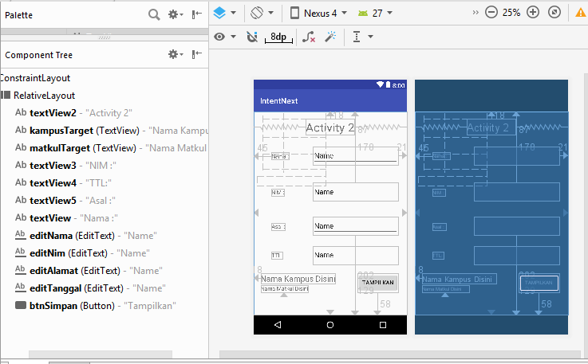

|  |
| --- |
| *<?***xml version="1.0" encoding="utf-8"***?>* <**android.support.constraint.ConstraintLayout xmlns:android="http://schemas.android.com/apk/res/android"  xmlns:app="http://schemas.android.com/apk/res-auto"  xmlns:tools="http://schemas.android.com/tools"  android:layout_width="match_parent"  android:layout_height="match_parent"  tools:context=".MainActivity2"**>   <**RelativeLayout  android:layout_width="match_parent"  android:layout_height="match_parent"  android:visibility="visible"  app:layout_constraintBottom_toBottomOf="parent"  app:layout_constraintEnd_toEndOf="parent"  app:layout_constraintHorizontal_bias="1.0"  app:layout_constraintStart_toStartOf="parent"  app:layout_constraintTop_toTopOf="parent"  app:layout_constraintVertical_bias="1.0"**>   <**TextView  android:id="@+id/textView2"  android:layout_width="wrap_content"  android:layout_height="wrap_content"  android:layout_alignParentTop="true"  android:layout_centerHorizontal="true"  android:layout_marginTop="18dp"  android:text="Activity 2"  android:textSize="30sp"** />   <**TextView  android:id="@+id/kampusTarget"  android:layout_width="wrap_content"  android:layout_height="wrap_content"  android:layout_alignParentStart="true"  android:layout_alignTop="@+id/btnSimpan"  android:layout_marginStart="18dp"  android:text="Nama Kampus Disini"  android:textSize="20sp"** />   <**TextView  android:id="@+id/matkulTarget"  android:layout_width="wrap_content"  android:layout_height="wrap_content"  android:layout_alignBottom="@+id/btnSimpan"  android:layout_alignStart="@+id/kampusTarget"  android:text="Nama Matkul Disini"** />   <**TextView  android:id="@+id/textView3"  android:layout_width="wrap_content"  android:layout_height="wrap_content"  android:layout_alignBaseline="@+id/editNim"  android:layout_alignStart="@+id/textView"  android:text="NIM :"** />   <**TextView  android:id="@+id/textView4"  android:layout_width="wrap_content"  android:layout_height="wrap_content"  android:layout_alignBaseline="@+id/editTanggal"  android:layout_alignStart="@+id/textView"  android:text="TTL:"** />   <**TextView  android:id="@+id/textView5"  android:layout_width="wrap_content"  android:layout_height="wrap_content"  android:layout_alignBaseline="@+id/editAlamat"  android:layout_alignStart="@+id/textView"  android:text="Asal :"** />   <**TextView  android:id="@+id/textView"  android:layout_width="wrap_content"  android:layout_height="wrap_content"  android:layout_alignBaseline="@+id/editNama"  android:layout_alignParentStart="true"  android:layout_marginStart="45dp"  android:text="Nama :"** />   <**EditText  android:id="@+id/editNama"  android:layout_width="wrap_content"  android:layout_height="wrap_content"  android:layout_alignParentEnd="true"  android:layout_alignParentTop="true"  android:layout_marginEnd="21dp"  android:layout_marginTop="87dp"  android:ems="10"  android:inputType="textPersonName"  android:text="Name"** />   <**EditText  android:id="@+id/editNim"  android:layout_width="wrap_content"  android:layout_height="wrap_content"  android:layout_alignParentTop="true"  android:layout_alignStart="@+id/editNama"  android:layout_marginTop="178dp"  android:ems="10"  android:inputType="textPersonName"  android:text="Name"** />   <**EditText  android:id="@+id/editAlamat"  android:layout_width="wrap_content"  android:layout_height="wrap_content"  android:layout_alignParentBottom="true"  android:layout_alignStart="@+id/editNama"  android:layout_marginBottom="202dp"  android:ems="10"  android:inputType="textPersonName"  android:text="Name"** />   <**EditText  android:id="@+id/editTanggal"  android:layout_width="wrap_content"  android:layout_height="wrap_content"  android:layout_alignParentBottom="true"  android:layout_alignStart="@+id/editNama"  android:layout_marginBottom="129dp"  android:ems="10"  android:inputType="textPersonName"  android:text="Name"** />   <**Button  android:id="@+id/btnSimpan"  android:layout_width="wrap_content"  android:layout_height="wrap_content"  android:layout_alignEnd="@+id/editNama"  android:layout_alignParentBottom="true"  android:layout_marginBottom="58dp"  android:text="Tampilkan"** />    </**RelativeLayout**>  </**android.support.constraint.ConstraintLayout**> |

1. Activity_main3

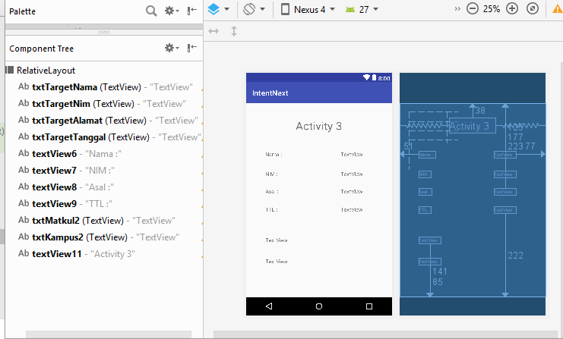

|  |
| --- |
| *<?***xml version="1.0" encoding="utf-8"***?>* <**RelativeLayout xmlns:android="http://schemas.android.com/apk/res/android"  android:layout_width="match_parent"  android:layout_height="match_parent"** >   <**TextView  android:id="@+id/txtTargetNama"  android:layout_width="wrap_content"  android:layout_height="wrap_content"  android:layout_alignParentEnd="true"  android:layout_alignParentTop="true"  android:layout_marginEnd="77dp"  android:layout_marginTop="125dp"  android:text="TextView"** />   <**TextView  android:id="@+id/txtTargetNim"  android:layout_width="wrap_content"  android:layout_height="wrap_content"  android:layout_alignParentTop="true"  android:layout_alignStart="@+id/txtTargetNama"  android:layout_marginTop="177dp"  android:text="TextView"** />   <**TextView  android:id="@+id/txtTargetAlamat"  android:layout_width="wrap_content"  android:layout_height="wrap_content"  android:layout_alignParentTop="true"  android:layout_alignStart="@+id/txtTargetNama"  android:layout_marginTop="223dp"  android:text="TextView"** />   <**TextView  android:id="@+id/txtTargetTanggal"  android:layout_width="wrap_content"  android:layout_height="wrap_content"  android:layout_alignParentBottom="true"  android:layout_alignStart="@+id/txtTargetNama"  android:layout_marginBottom="222dp"  android:text="TextView"** />   <**TextView  android:id="@+id/textView6"  android:layout_width="wrap_content"  android:layout_height="wrap_content"  android:layout_alignParentStart="true"  android:layout_alignTop="@+id/txtTargetNama"  android:layout_marginStart="51dp"  android:text="Nama :"** />   <**TextView  android:id="@+id/textView7"  android:layout_width="wrap_content"  android:layout_height="wrap_content"  android:layout_alignStart="@+id/textView6"  android:layout_alignTop="@+id/txtTargetNim"  android:text="NIM :"** />   <**TextView  android:id="@+id/textView8"  android:layout_width="wrap_content"  android:layout_height="wrap_content"  android:layout_alignStart="@+id/textView6"  android:layout_alignTop="@+id/txtTargetAlamat"  android:text="Asal :"** />   <**TextView  android:id="@+id/textView9"  android:layout_width="wrap_content"  android:layout_height="wrap_content"  android:layout_alignStart="@+id/textView6"  android:layout_alignTop="@+id/txtTargetTanggal"  android:text="TTL :"** />   <**TextView  android:id="@+id/txtMatkul2"  android:layout_width="wrap_content"  android:layout_height="wrap_content"  android:layout_alignParentBottom="true"  android:layout_alignStart="@+id/textView6"  android:layout_marginBottom="141dp"  android:text="TextView"** />   <**TextView  android:id="@+id/txtKampus2"  android:layout_width="wrap_content"  android:layout_height="wrap_content"  android:layout_alignParentBottom="true"  android:layout_alignStart="@+id/textView6"  android:layout_marginBottom="85dp"  android:text="TextView"** />   <**TextView  android:id="@+id/textView11"  android:layout_width="wrap_content"  android:layout_height="wrap_content"  android:layout_alignParentTop="true"  android:layout_centerHorizontal="true"  android:layout_marginTop="38dp"  android:text="Activity 3"  android:textSize="30sp"** /> </**RelativeLayout**> |

1. Hasil

